CAPSTONE PROJECT DOCUMENTATION
PROJECT 5—POLICY, COMPLIANCE AND SUMMARY
1) AI Identity Security Policy
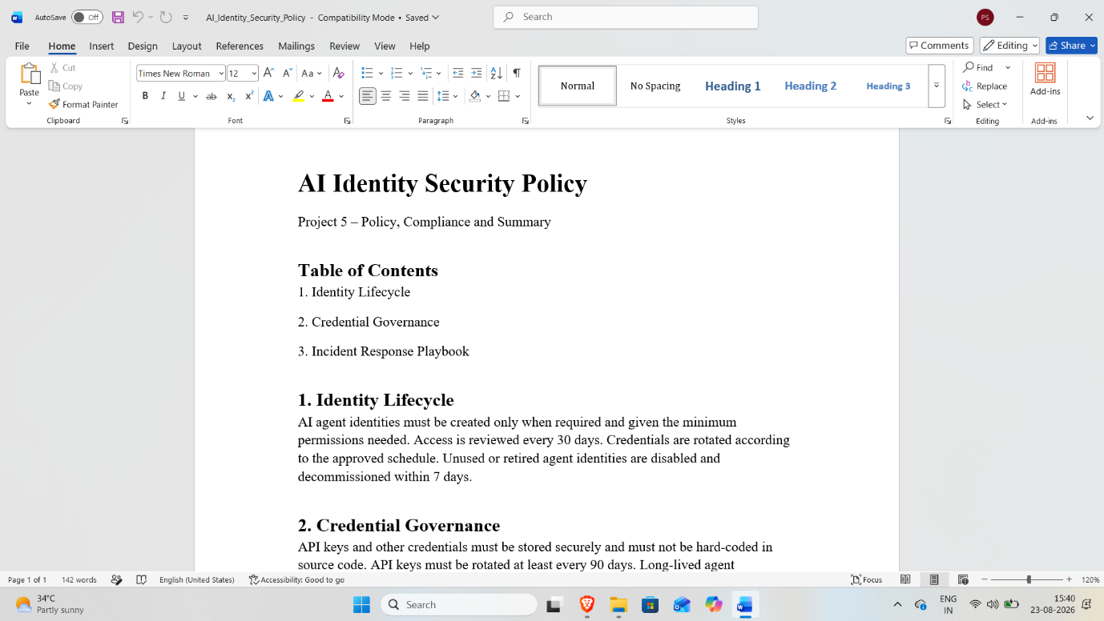
Created an AI Identity Security Policy covering identity lifecycle, credential governance, and incident response.

2) Incident Response Playbook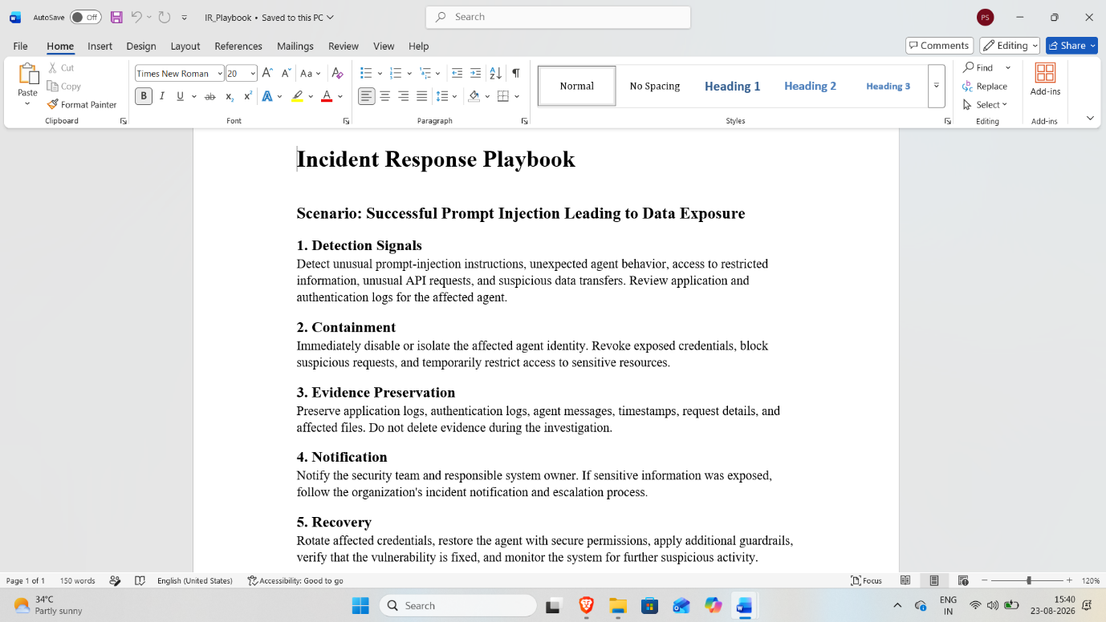
Created an incident response playbook covering detection, containment, evidence preservation, notification, and recovery.
3) NIST AI RMF Compliance Mapping
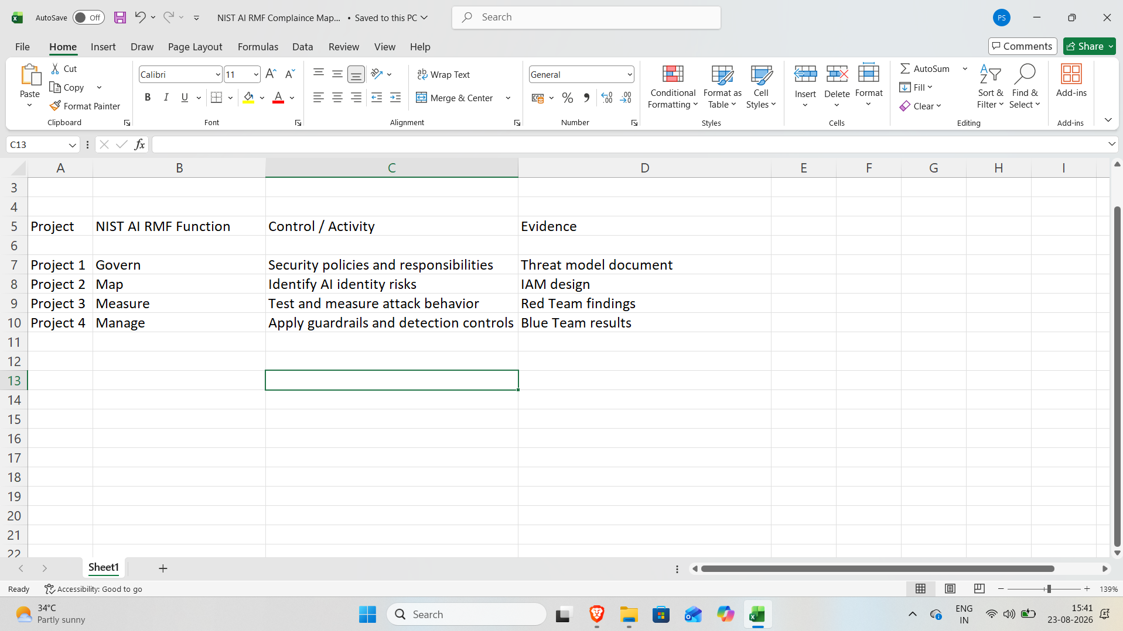
Mapped Projects 1–4 security activities to the NIST AI RMF functions: Govern, Map, Measure, and Manage.

4) OWASP LLM Top 10 Security Mapping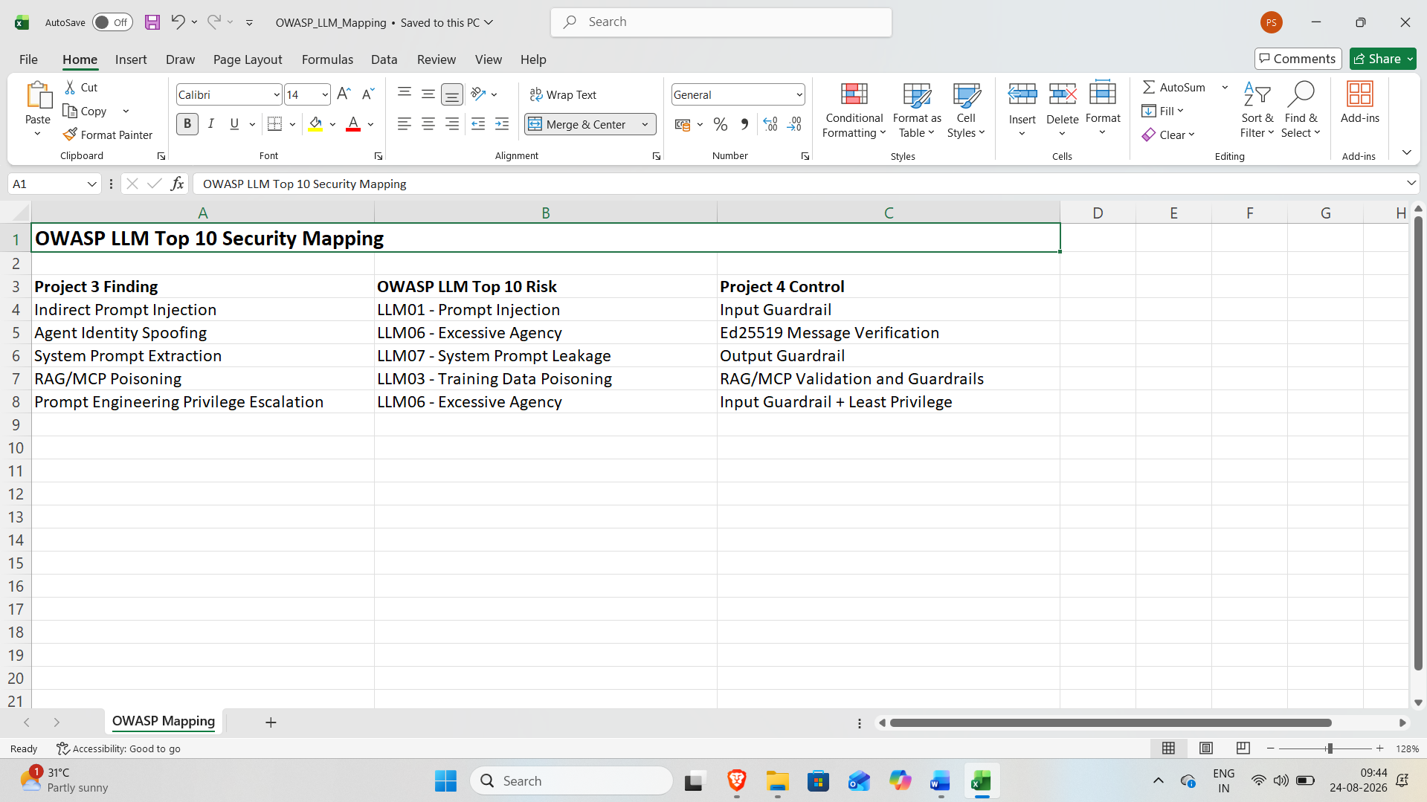
Mapped the five Project 3 attack findings to relevant OWASP LLM risks and corresponding Project 4 security controls.

5) GitHub Repository Evidence
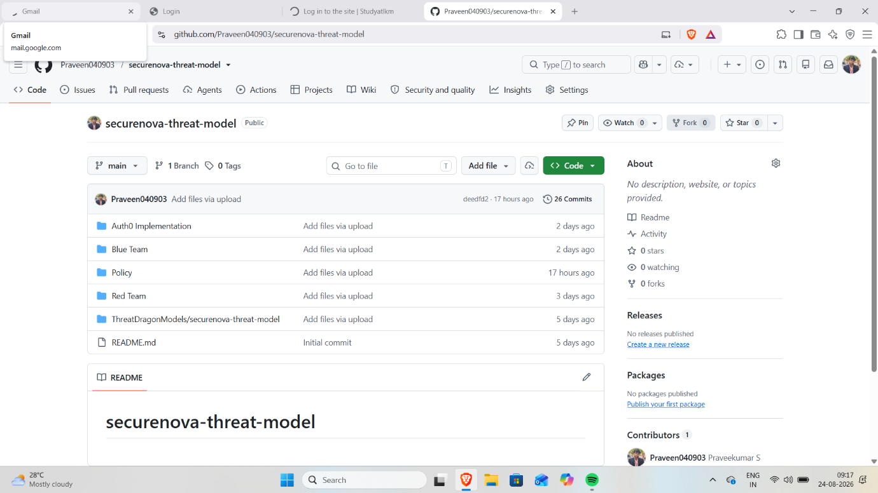
GitHub repository showing all five project folders and the completed project artifacts.

6) GitHub Commit History
A)
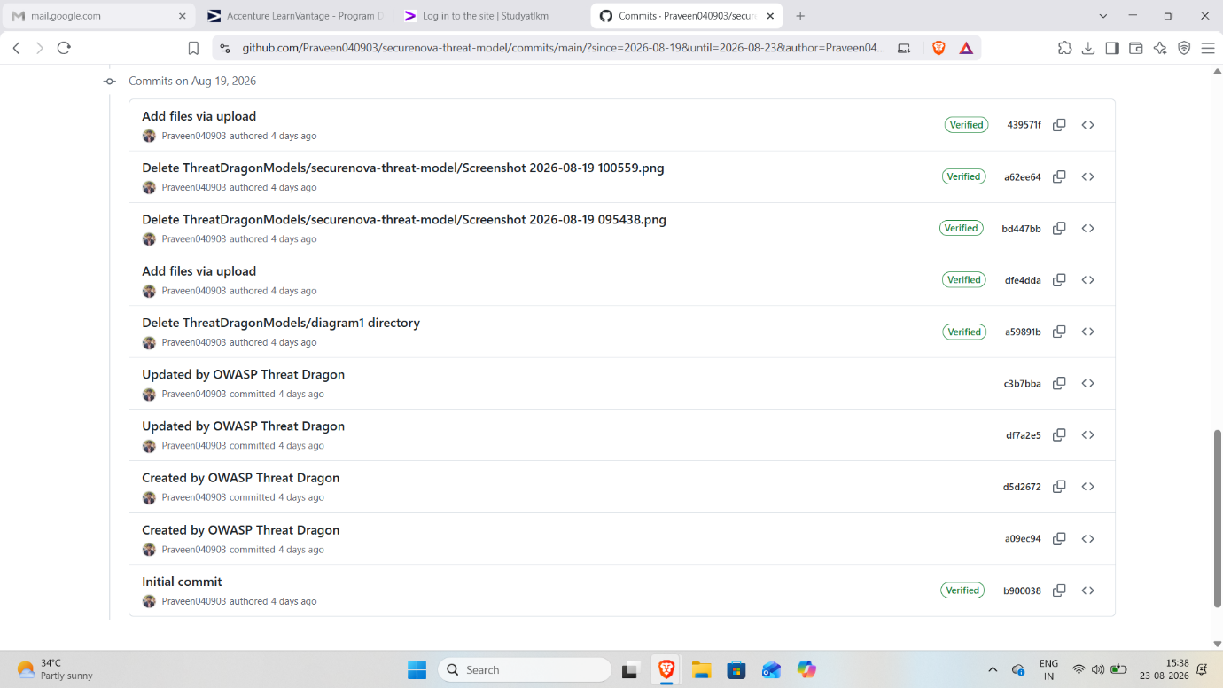

B)
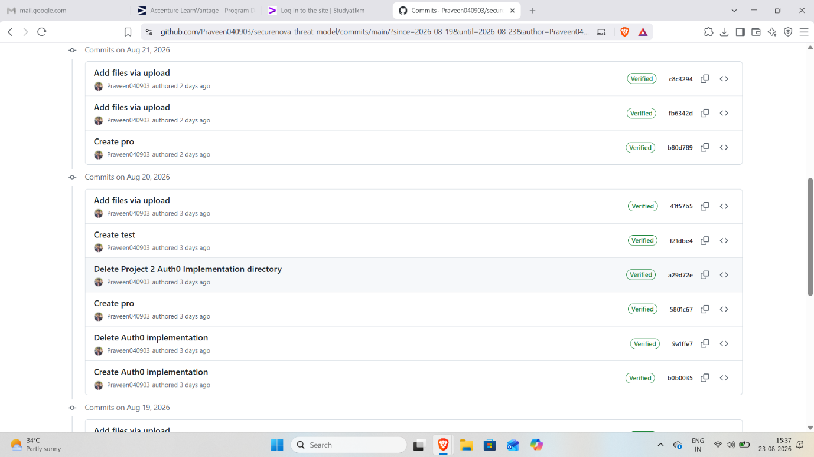
C)
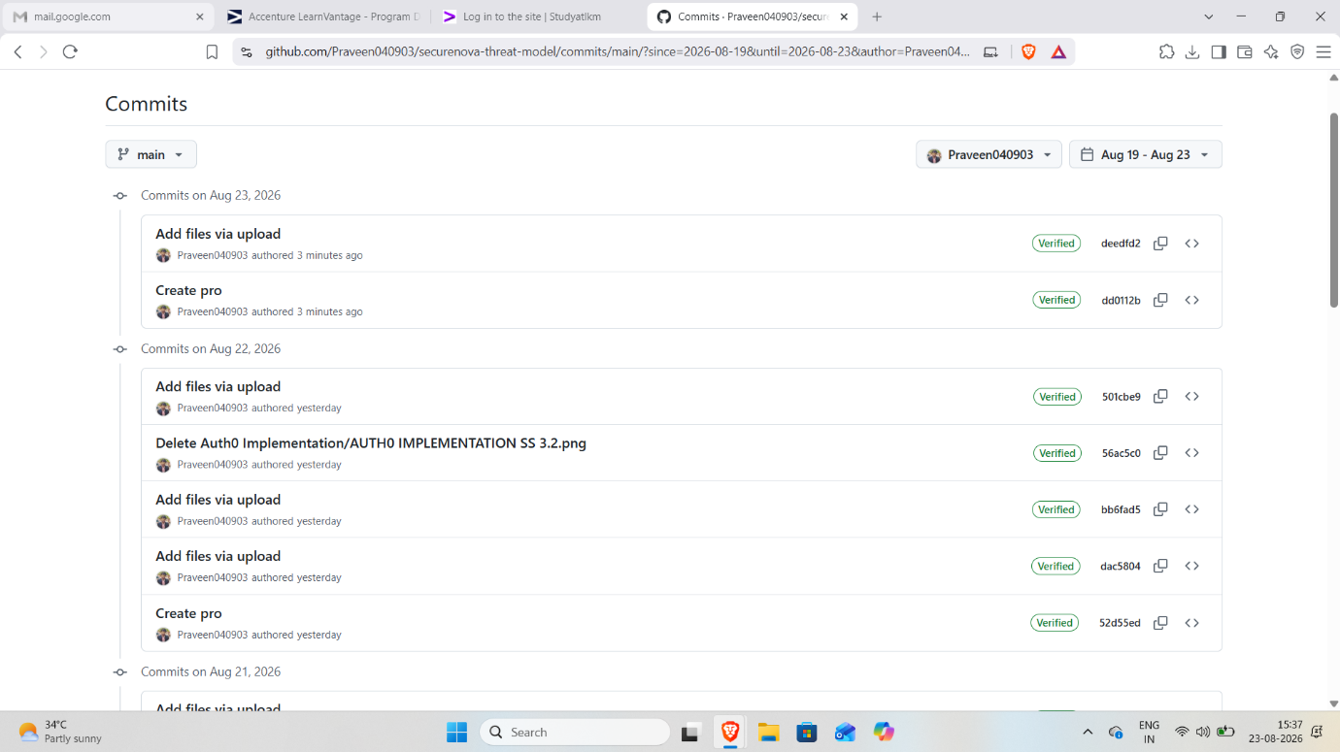
GitHub commit history showing development contributions across the five project days.

7) Risk Priority Matrix
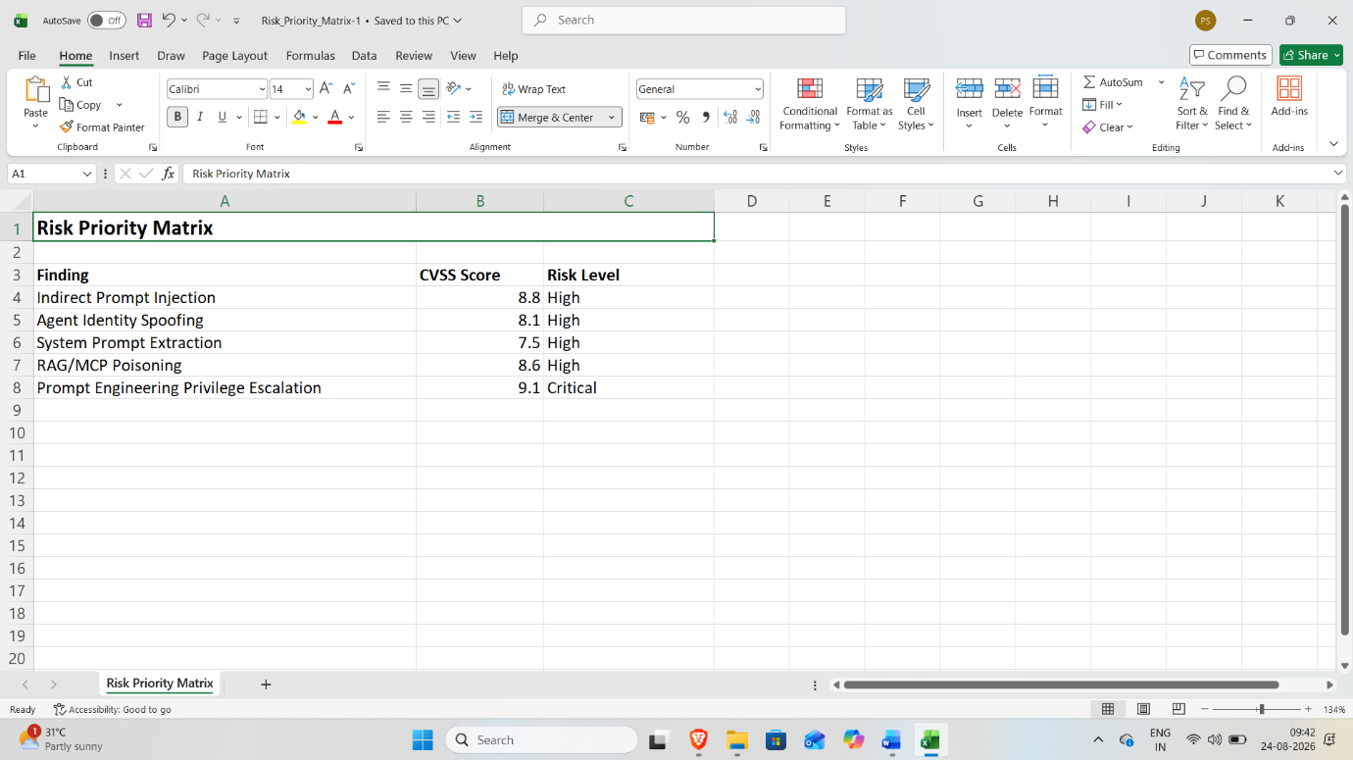
Created a risk priority matrix containing the five Project 3 findings, CVSS scores, and risk levels.

8) Top 5 Security Recommendations
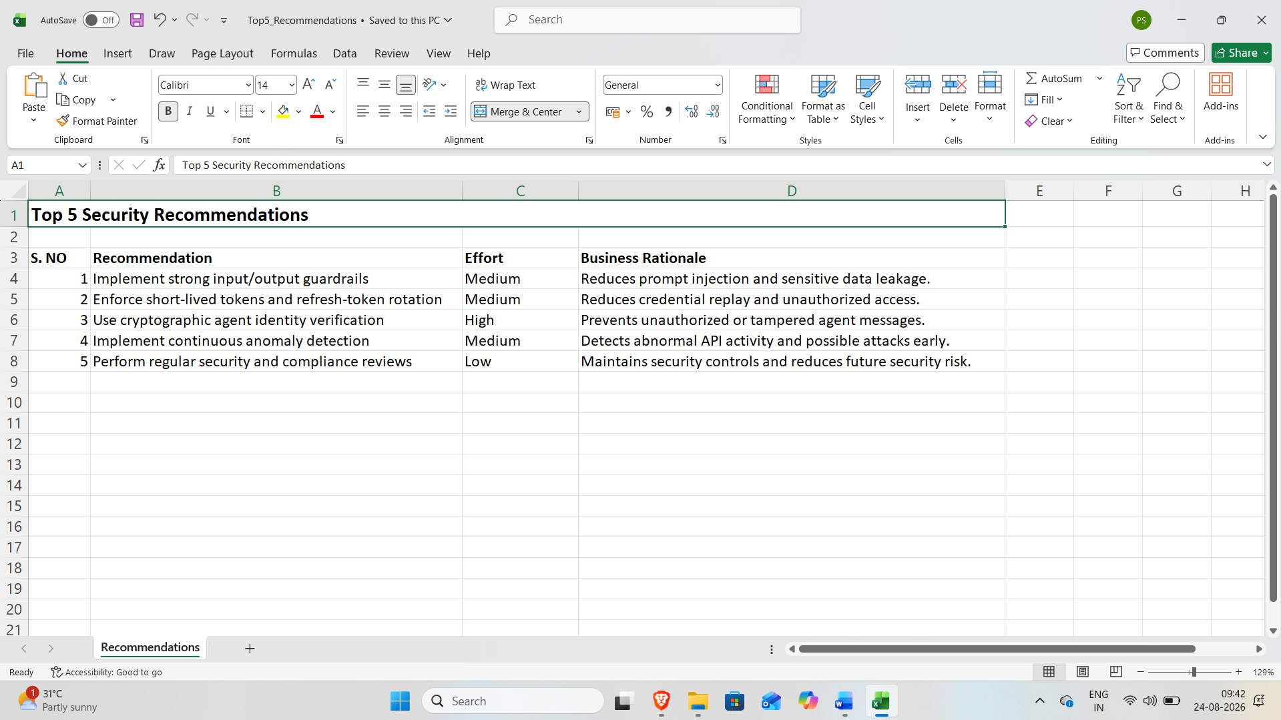
Provided five security recommendations with effort estimates and business rationale to improve AI identity security

